

CSI OT 3D Platform Cyber Attack Demonstration Control Website

Design Manual

VERSION: CORPLAB-2021-T5F-A1

30/03/2021

Prepared by

Liu Yuancheng

Senior Security Development Engineer

<yuancheng.liu@trustwave.com>

Wong Jun Wen

Asst R&D Manager

<junwen.wong@trustwave.com>

Dr. Shantanu Chakrabarty

NUS Research Fellow

<shantanu1088@gmail.com>

Confidentiality Notice: This document is confidential and contains proprietary information and intellectual property of Trustwave, a Singtel company, its parent company and its subsidiaries. Neither this document nor any of the information contained herein may be reproduced or disclosed under any circumstances. Please be aware that disclosure, copying, distribution or use of this document and the information contained therein is strictly prohibited.

**CSI OT 3D Platform Cyber Attack Demonstration Control Website Design and Usage Manual**

**1. Project Introduction**

The “CSI OT 3D Platform Cyber Attack Demonstration Control Website” is a web interface dashboard to let the user to control different cyber-attack demos on OT 3D railway module platform and check the attack feedback during the presentation. This manual will introduce the web host program detail workflow, program structure and the usage of the webpage which shown on the Orchestrator PC.

1.1 Webpage View:

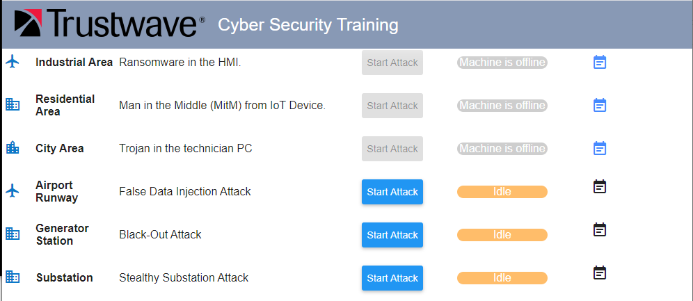

**New Feature**

* Open a web browser on Orchestrator PC and type in link: <http://localhost:8080/> .

1.2 Orchestrator PC (server) View:

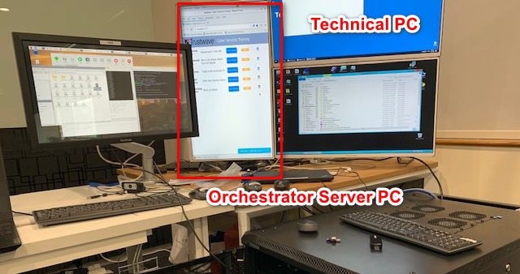

**Orchestrator PC**

* Orchestrator PC Login part refer to doc < CSI OT 3D Platform Cyber Attack Demonstration User Manual.pdf >

**2. Web Host Program Workflow**

**2.1 System Control Flow**

In our system, the cyberattack action is implemented the by the attack device (Raspberry PI), the web host will send the control command to the attack device through UDP [port 5005/5006]. The Control Flow Diagram of the System is shown below:

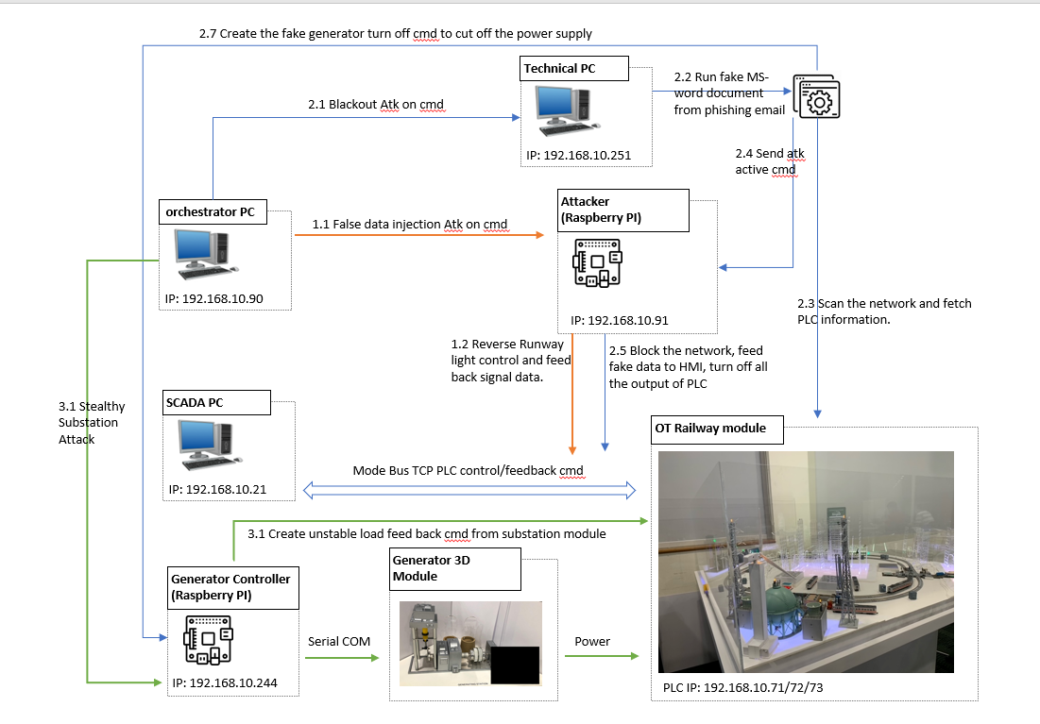

As shown in the above diagram, the Web host program will communicate with the Attack Raspberry PI (section 1.1) and the Generator Control Raspberry PI (section 3.1) by UDP through. When the user pressed the “Start Attack” button, the web host will send the attack activation command to the related agent program running on technical PC or the attack device. After you press the ‘Start Attack’ button, the text on the button will change to ‘Stop Attack’ which means the attack is under progress. (As shown in the below image)

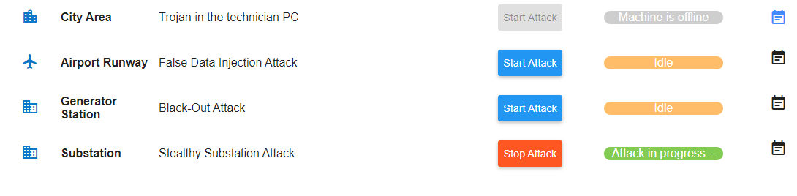

**2.2 Attack Control Command**

All the action trigger commands are sent through UDP under format **<ctrlTag>;<parameter>**. Attack control tag is “A” and the parameter specify starting different attack, 0 for stopping attack.

2.2.1 False Data Injection Attack [From **App.js** to **attackServer.py**, port:5005]: (Todo: the path of the program)

UDP Channel: Orchestrator PC (192.168.10.90) => Attack Raspberry PI (192.168.10.91) [Port 5005]

UDP message: Start Attack: '**A;2**' Stop Attack: ‘**A;0**’

2.2.2 Black Out Attack [From **App.js** to **actionServer.py**, port:5006]:

UDP Channel: Orchestrator PC (192.168.10.90) => Technical PC (192.168.10.251)

UDP message: Start Attack: '**A;2**' Stop Attack: ‘**A;0**’

2.2.3 Stealthy Substation Attack [From **App.js** to **pwrGenMgr.py**, port:5005]:

UDP Channel: Orchestrator PC (192.168.10.90) => Generator Control Raspberry PI (192.168.10.244)

UDP message: Start Attack: '**A;3**' Stop Attack: ‘**A;0.**’

**3. Website Host Program Setup**

**3.1 Program execution environment configuration**

3.1.1 Development environment:

NodeJs(v12.18.4)/JavaScript HTML5

* + 1. Additional lib/software need:

NodeJs(v12.18.4) (Download and Install NodeJs : https://www.guru99.com/download-install-node-js.html)

* + 1. Hardware needed:

Orchestrator PC with Centos 7

* + 1. Program execution cmd:

Cd to the "server" folder, run cmd **Node app.js**

**3.2 First time setup the website host program on a computer:**

3.2.1 Copy the server folder to the computer and setup the auto run service during the system boots up: create a new service unit file at **/etc/systemd/system/httpserver.service** with below content. The name of the service unit is user defined and can be any name of your choice.

[Unit]

Description=server side for GUI

After=network.target

[Install]

WantedBy=multi-user.target

Alias=webservice.service

[Service]

Type=simple

User=root

Group=root

# Start main service

ExecStart=/home/orchestrator/Attack/server/server/node /home/orchestrator/Attack/server/server/app.js

# Give up if ping don't get an answer

TimeoutSec=20

Restart=always

3.2.2 Reload the systemd process to consider newly created httpserver.service OR every time when httpserver.service gets modified:

**# systemctl daemon-reload**

3.2.3 Enable this service to start after reboot automatically:

# **systemctl enable httpserver.service**

3.2.4 Start the service:

# **systemctl start httpserver.service**

3.2.5 Reboot the host to verify whether the scripts are starting as expected during system boot.

# **systemctl reboot**

After finishing the above step, server will run automatically when the computer was powered on.

**4. Program File Structure**

**4.1 Program File List**

All the source code are under the server folder:

| **Program File/Folder** | **Execution Env** | **Description** |
| --- | --- | --- |
| node_modules [Folder] | Node.js(JavaScript) | All the additional module which needed to import in the app.js |
| Public [Folder] | HTML, CSS, JavaScript | The main web page interface. |
| app.js | Node.js(JavaScript) | Main server program. |
| httpserver.service | sh | Auto run setup when running on Linux Platform. |
| playAlert.sh | sh | Play the alert sound when the attack happens. |
| runServer.sh | sh | Run the app.js and stop the duplicated running if found. |

You can clone the source code from: <https://github.com/LiuYuancheng/OT_Platform_Attack_Web>

**5. Reference**

N.A

End (last edited 10/04/2021)